Install R, RStudio and a Text Editor:

The date of the workshop has almost arrived. Try to install R and R studio on your personal computer before arriving at the workshop. Follow the instructions below. (If you don’t succeed, fear not! Try to come a few minutes early, and I will help you :)

1. Go to: <https://rstudio.com/products/rstudio/download/>
2. Click “Download” below “R Studio Desktop”

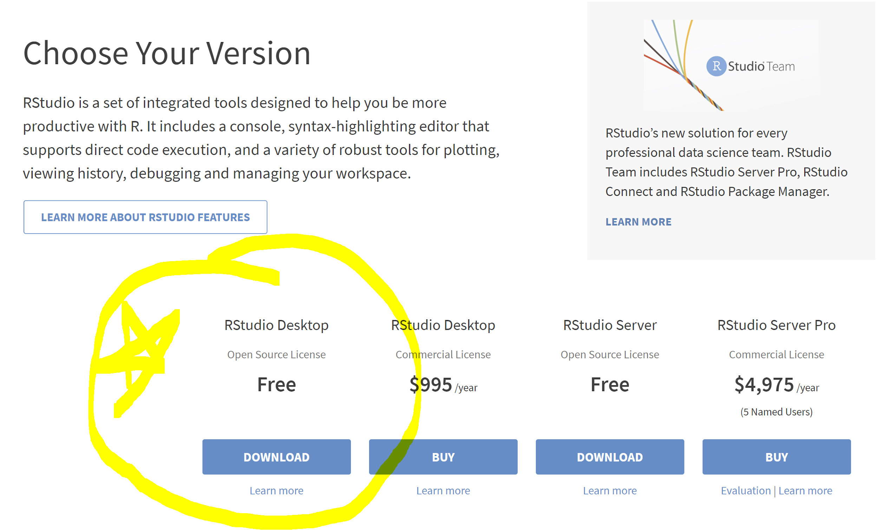

1. The instructions to download RStudio will appear in the page that opens
2. Before installing RStudio, first install R by clicking the link in step 1

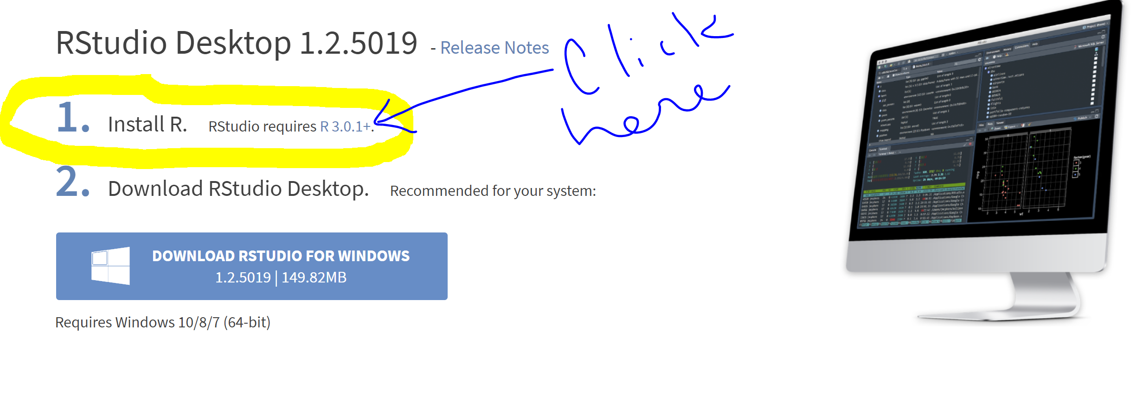

1. This link will take you the Comprehensive R Archive Network website.
2. Click on the “Download” link that matches the operating system of your computer

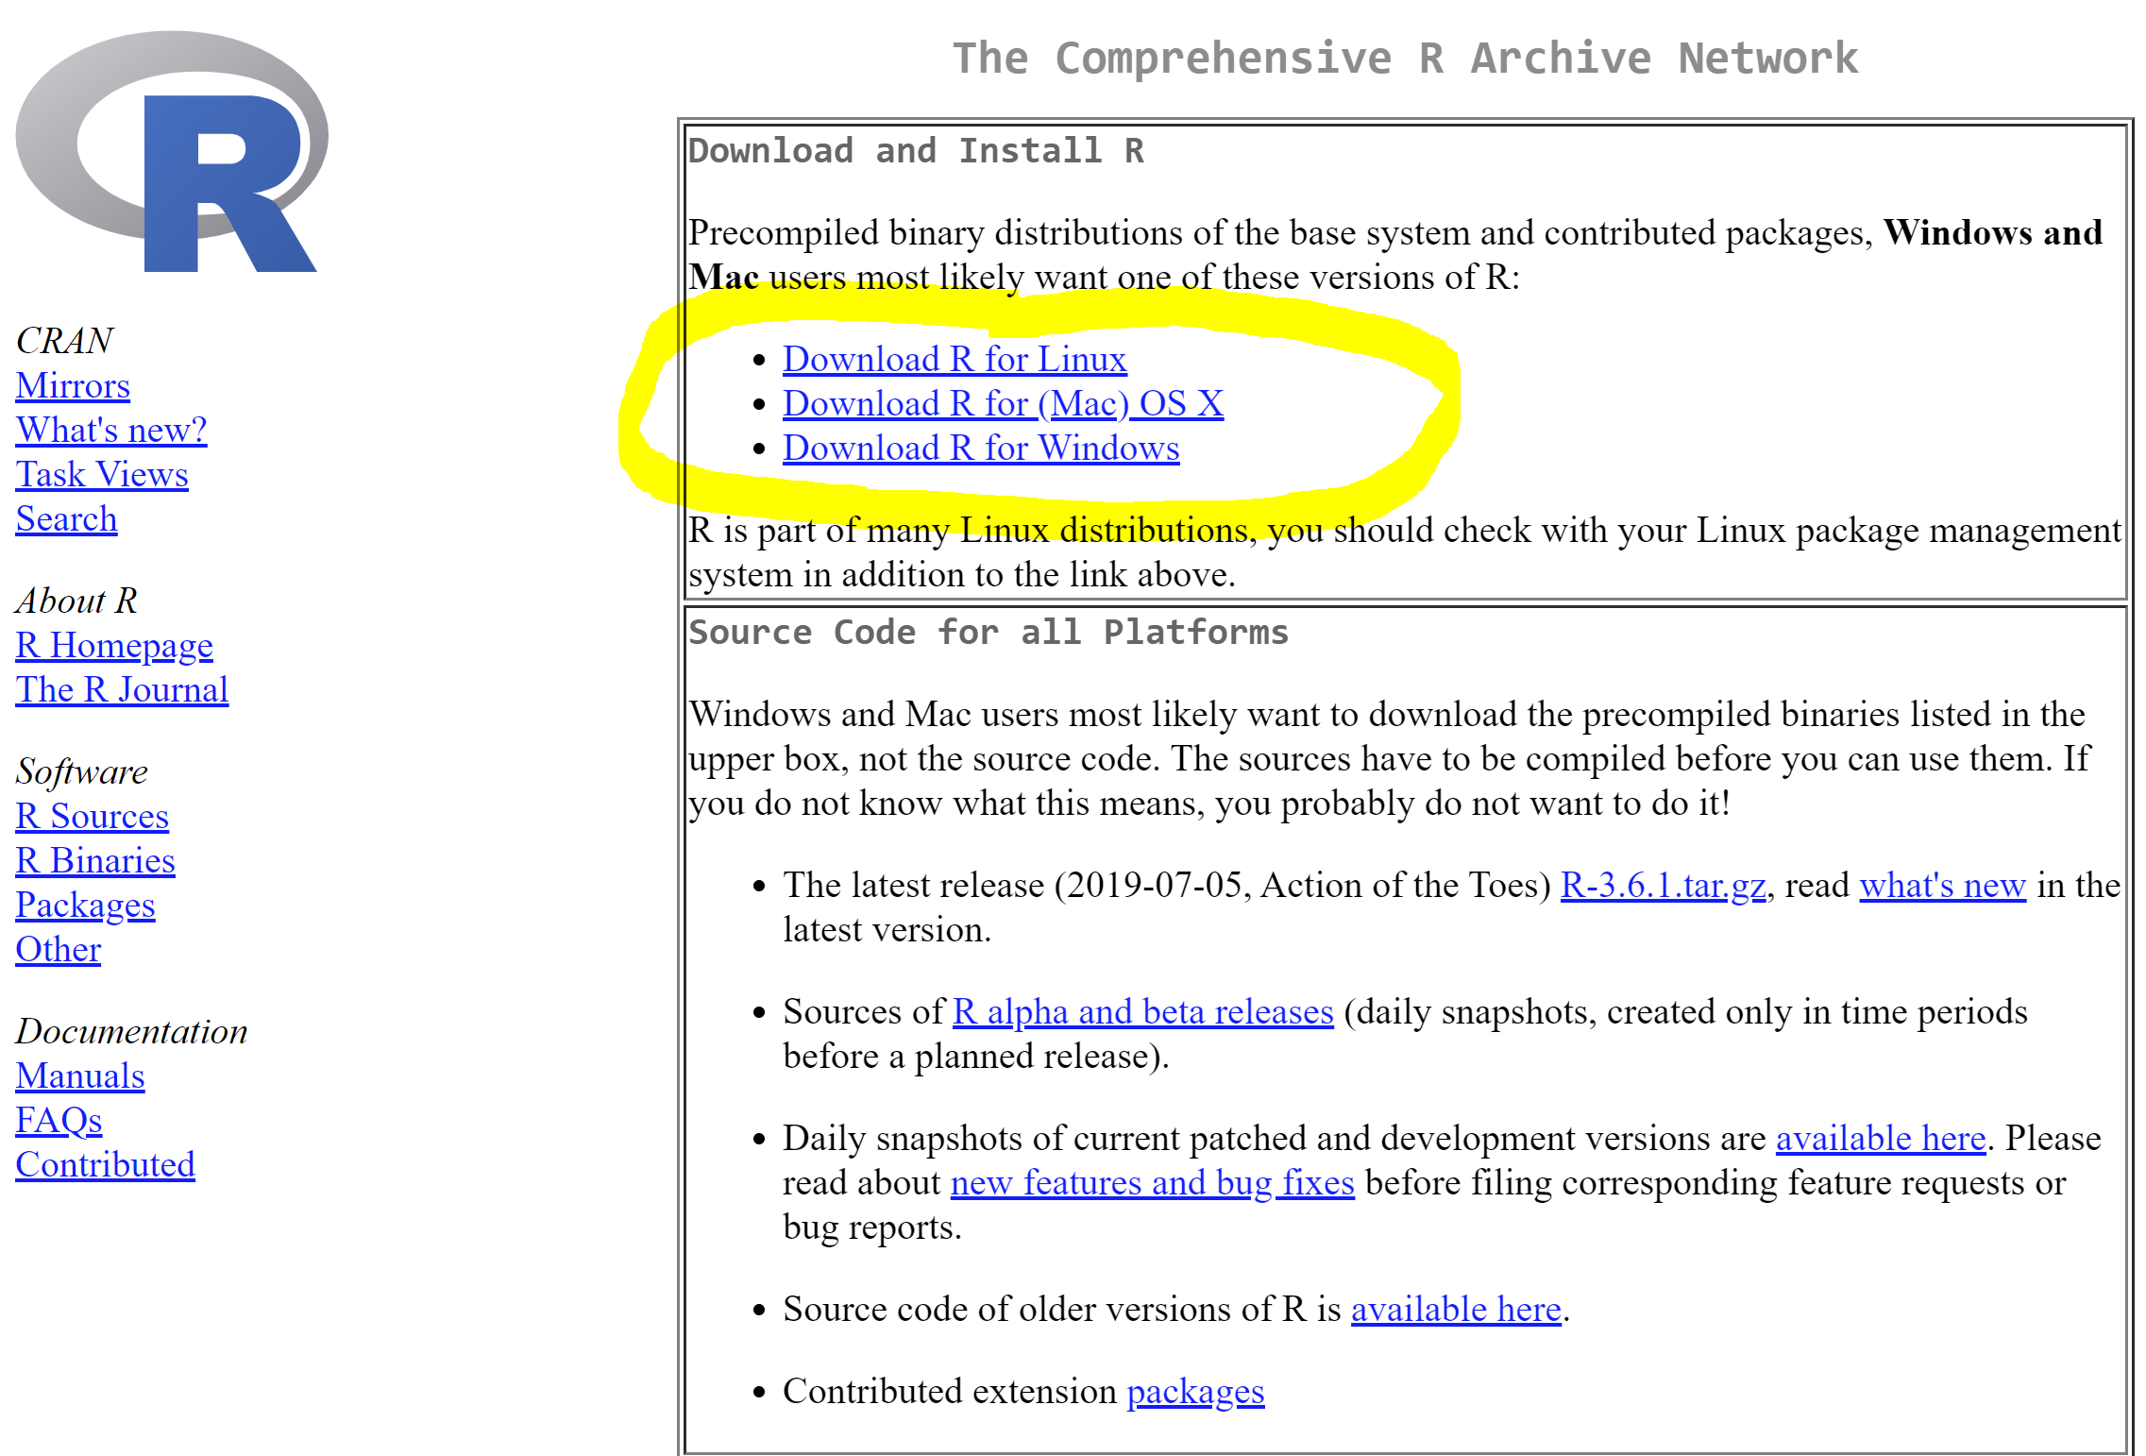

Windows Installation:

Hey, Hey! You use Windows! Me too!

7-Windows) When you click the “Download R for Windows” Link, you will see this page:

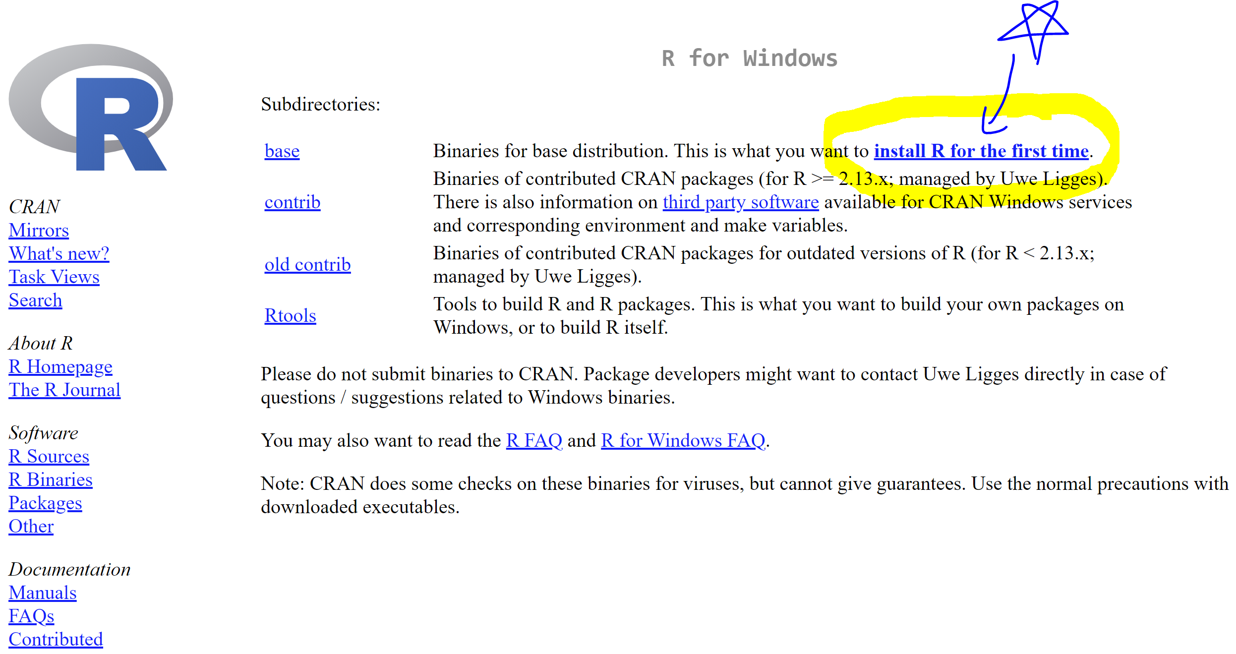

8-Windows) Click the “install R for the first time” link

9-Windows) On the next page, choose the “Download R 3.6.1 for Windows” link

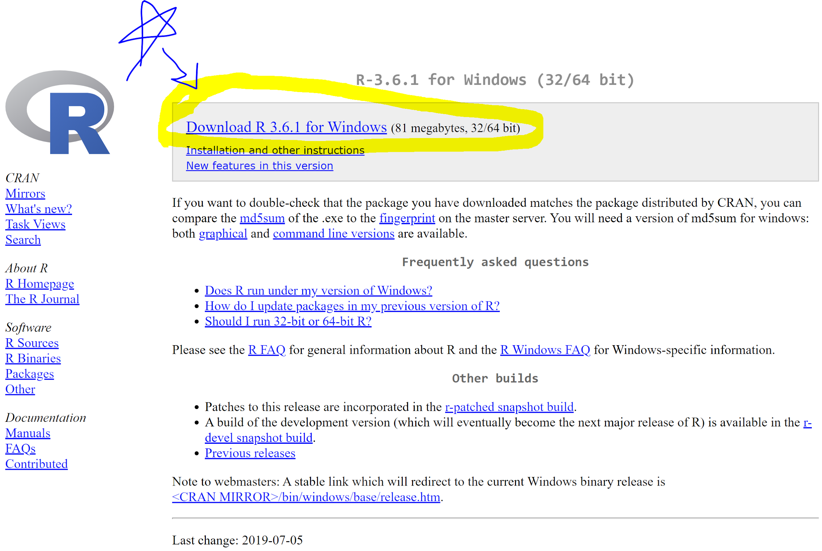

10-Windows) Download of R will begin

11-Windows) Find this file where your internet browser puts newly downloaded files (this is likely “Downloads”)

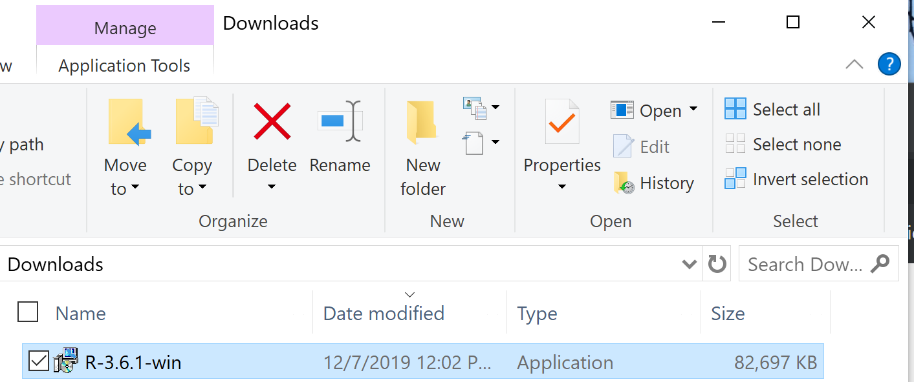

12-Windows) It should be called R-3.6.1-win

13-Windows) Double click it

14-Windows) Go through the setup prompts

15-Windows) You can leave all the default options as they are

16-Windows) (Once you are done with this, you can go back to the RStudio link from step 4)

……

You have a Mac? Rad!



7-Mac) From this page choose “Download R for (Mac) OSDownload R for (Mac) OS X”

8-Mac) At this point you need to check what version of OS X you are running.

9-Mac) This link will help you find that information: <https://support.apple.com/en-us/HT201260>

10-Mac-A) **IF your OS X version is 10.11, 10.12, 10.13, 10.14, or 10.15**:

Click the link “R-3.6.1.pkg”

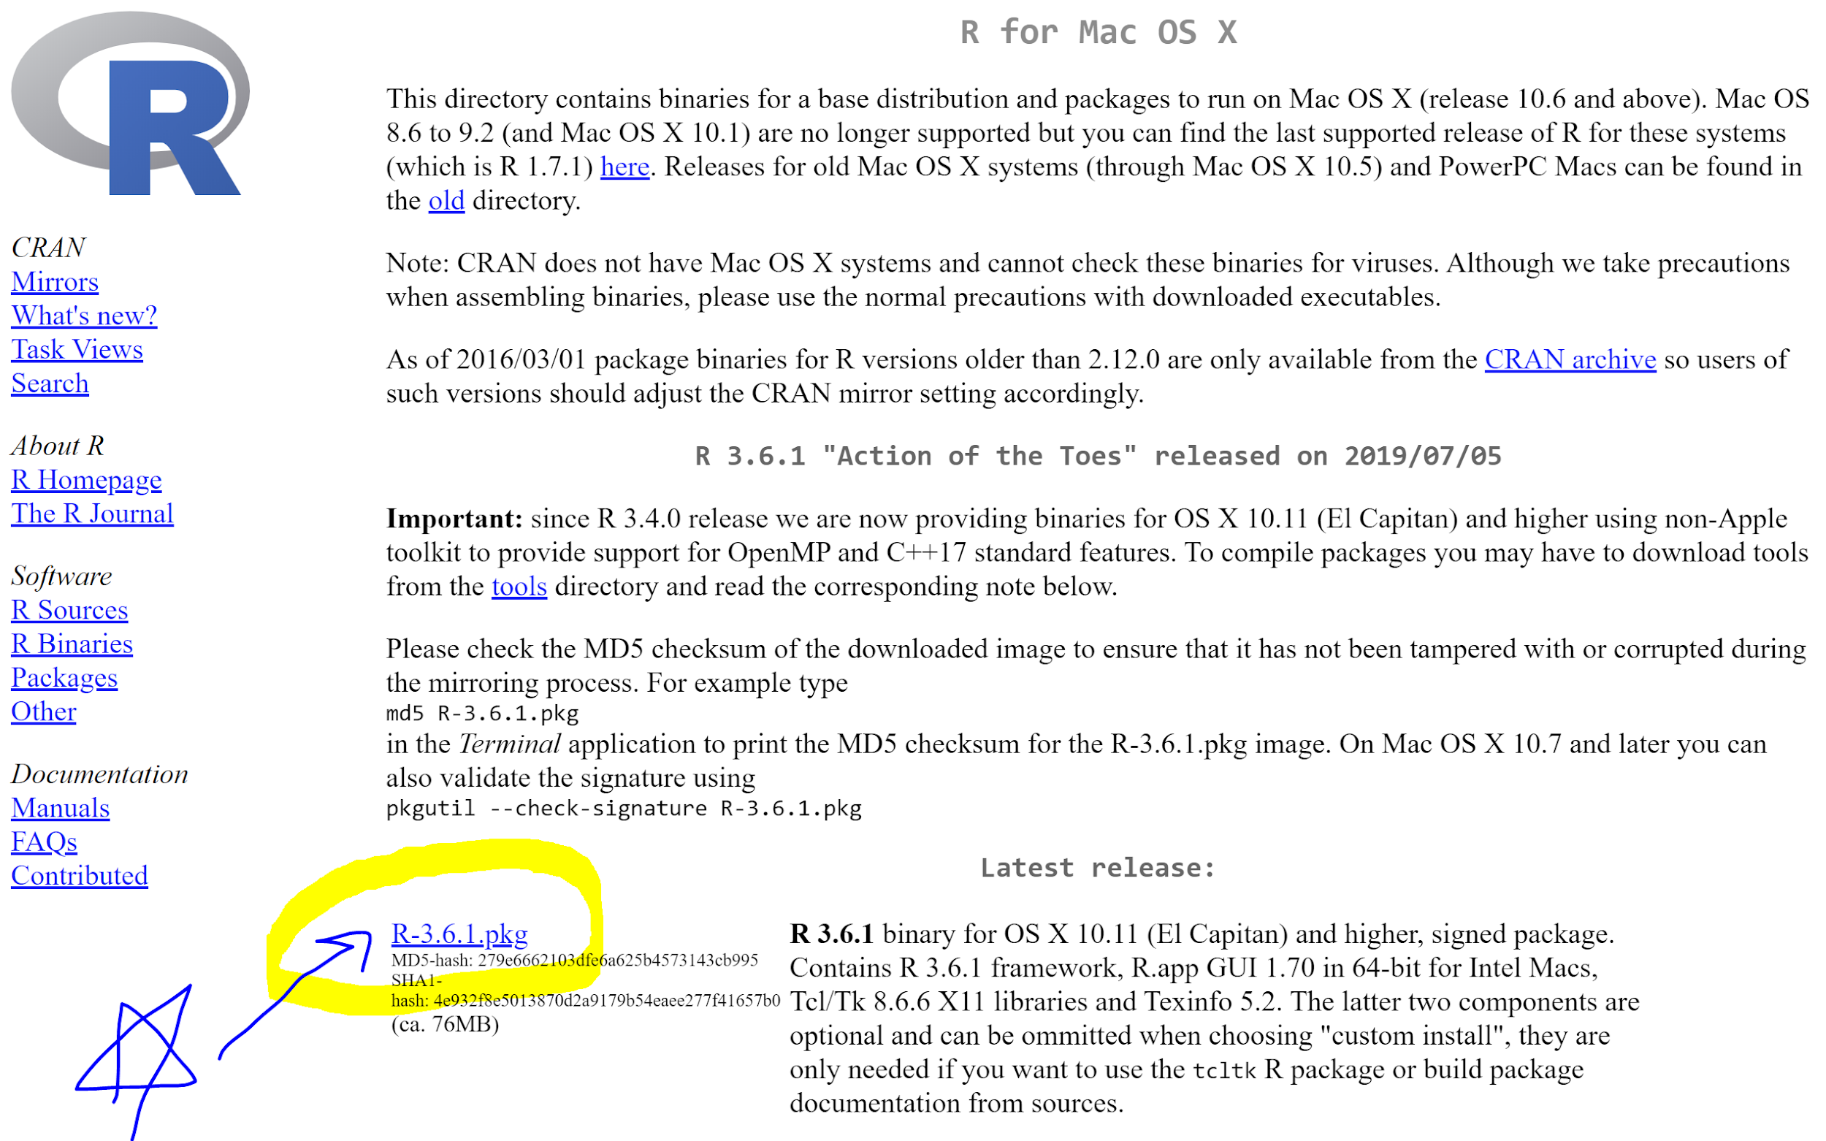

*Skip this step if you just downloaded R in the previous step*

10-Mac-B) **IF your OS X version is 10.10 or lower,**

Click the link “R-3.3.3.pkg”

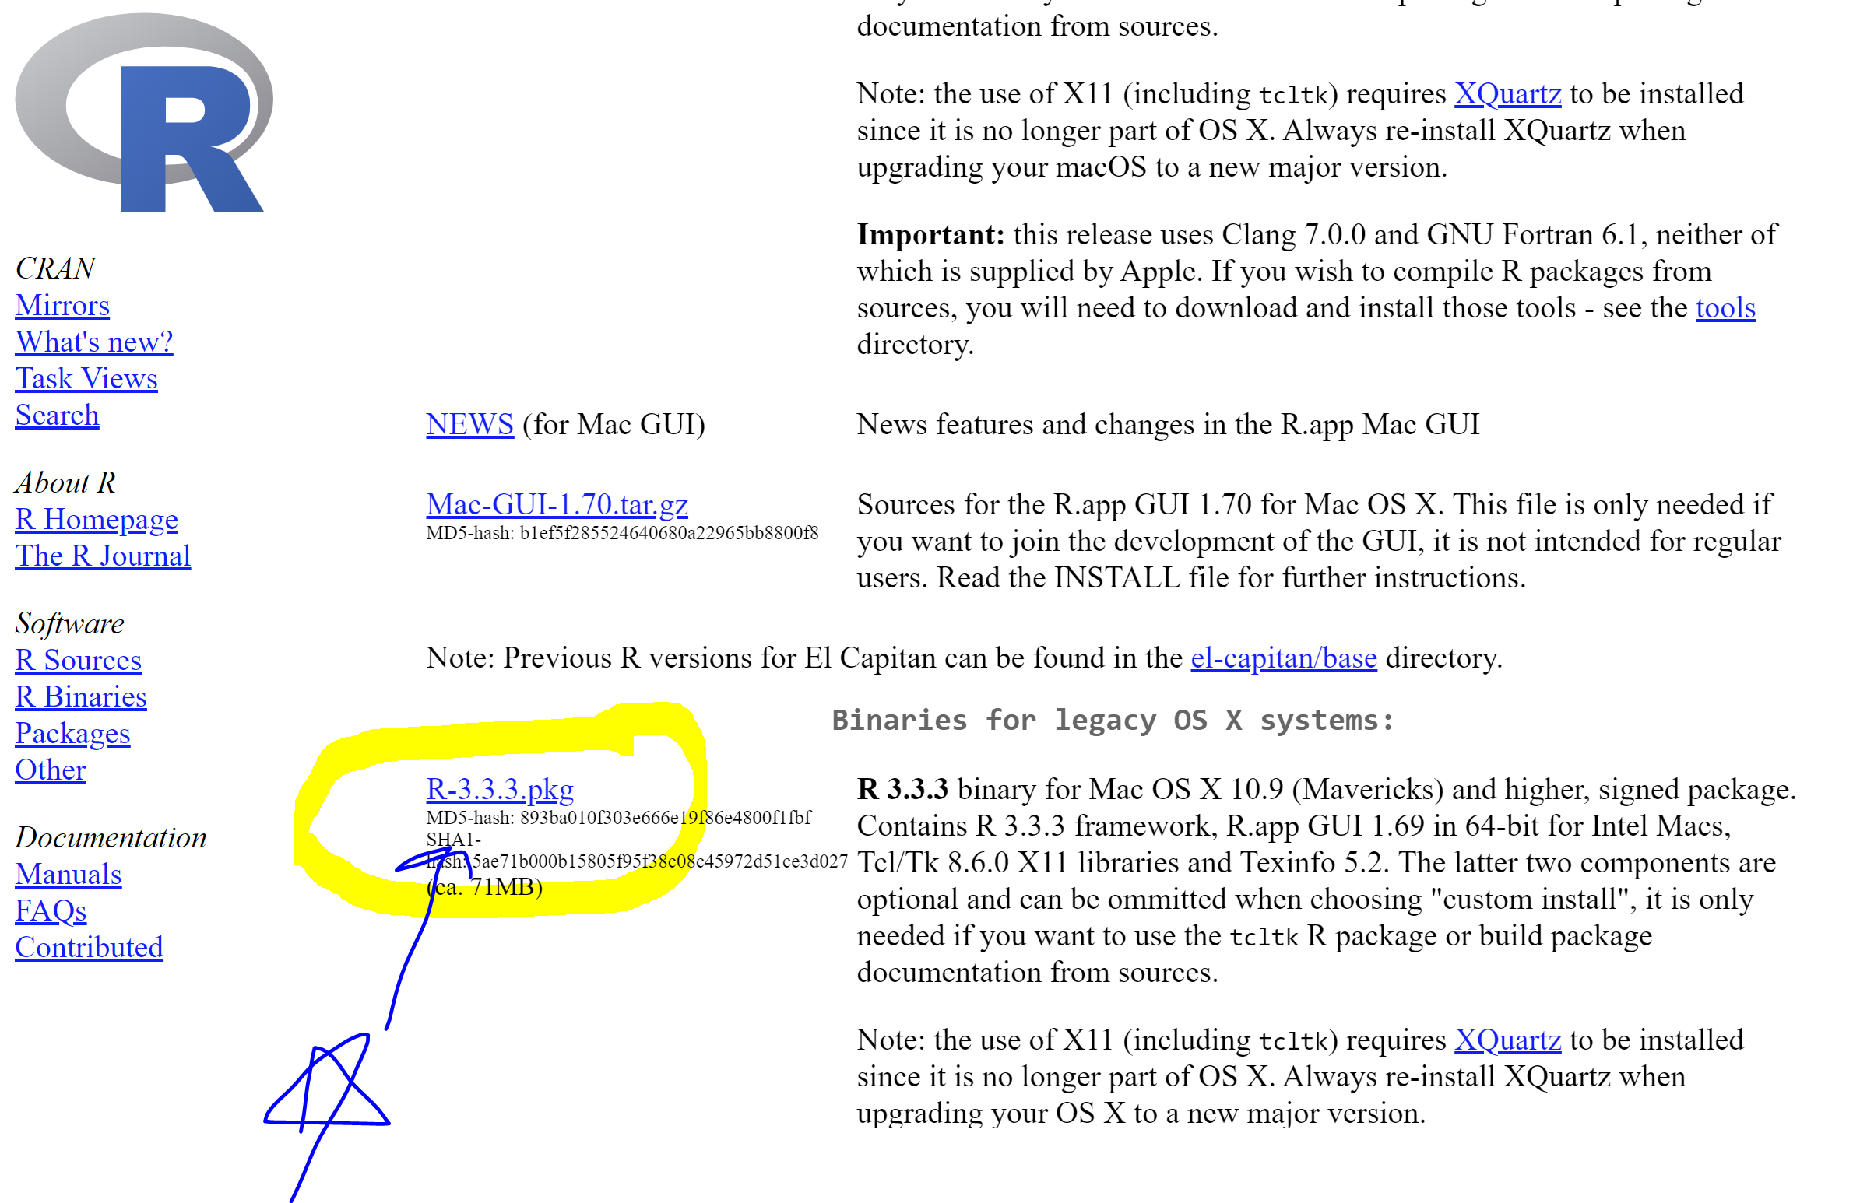

11-Mac) Clicking these will initiate the R download

12-Mac) Find the file that was just downloaded (Probably in “downloads”)

13-Mac) Double click it

14-Mac) Go through the setup prompts

15-Mac) You can leave all the default options as they are

16-Mac) (Once you are done with this, you can go back to the RStudio link from step 4)

……

You use Linux? Oh wow! You are smarter than me!



Click the “Download R for Linux”

From here, I can’t help you.

But I bet you are really good at computers and you will know exactly know what to do!

If you hit a snag, Google will have the answer!

…….

R is installed!

Now let’s go back to the RStudio Download link from step 4:

17) Click the box that says “Download R Studio for {Your Operating System}”

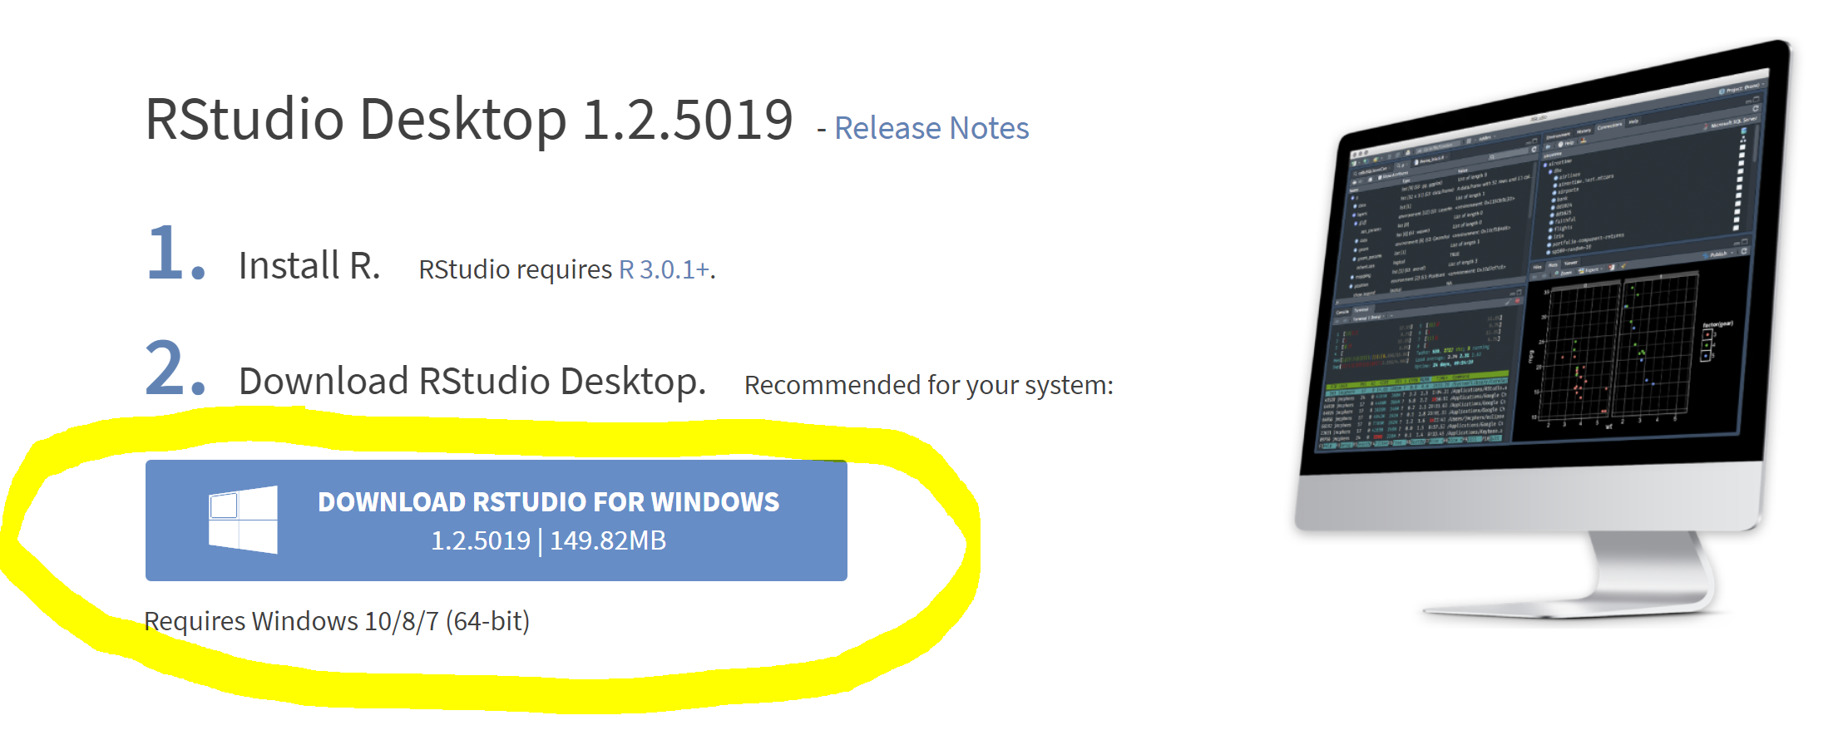

18) Find the file that was just downloaded

19) Double click it

20) Go through the setup prompts

21) You can leave all the default options as they are

22) At this point, you should have an RStudio icon in your “Applications” folder if you have a Mac or in your Start Menu if you have Windows.

23) Open RStudio:

Does it look something like this? (The files in the bottom right panel will vary based on your personal computer) If so, you should be good to go.

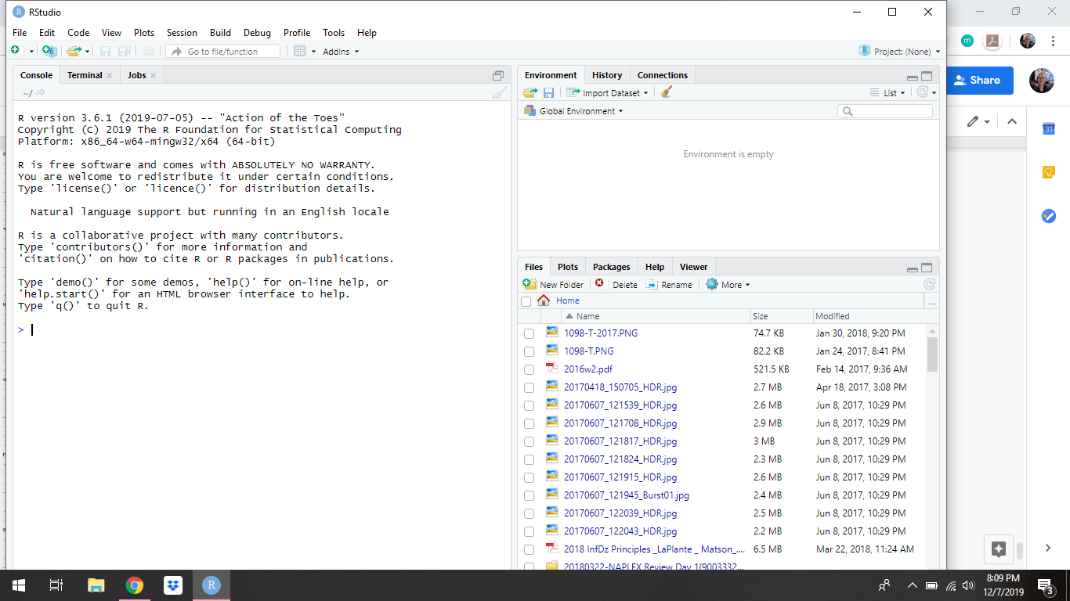

Last Thing:

Install a text editor. Notepad is fine, but there are many programming specific text editors that have additional useful functionalities. I use Sublime Text. (If you already have a favorite text editor, skip this step)

Go to this website to download. Follow the instructions to download and install.

<https://www.sublimetext.com/>

** At a certain point, it will prompt you with an option to buy a license for the software. This is optional. You can click “Later” and it will leave you alone for a couple of weeks before bugging you again.